THE NEW ALBANY PRESBYTERIAN CHURCH
P.O. Box 906 – Highway 15 South
New Albany, Mississippi 38652

Church Office and Pastor Email
(662) 534-6060 napresch@gmail.com

THE SESSION
(Meeting 2nd Tuesday, Monthly)
Robby Hall - 2023 Al Campbell – 2025
John Harlow – 2023 Bradley Littlejohn – 2025
Don Nichols – 2024 Bruce Ballard – 2026
Will Henson – 2024 Thomas Maclin – 2026
THE DIACONATE
(Meeting 1st Sunday, Monthly)
Jeff Covington – 2023 John Taylor – 2024
Walt Henson – 2023 Ryan Murry – 2025
Lee Henson – 2023 Sam Cobb – 2026
Jonathon Morris – 2023 Braxton Dowdy – 2026
Harry Briscoe – 2024 Steven Lofton – 2026
Britt Jackson – 2024

WOMEN OF THE CHURCH
Mrs. Cassie Henson – President
Mrs. Grace Henson – Vice President
Mrs. Diane Aldridge – Sec./Treas.

STAFF
The Rev. William B. Everett………………….………………………………Pastor Emeritus
Mr. Stephen Ewing……………………………………………………………...Stated Supply
Mr. Ben Storment……………………………………….Dir. of Youth and Family Ministries
Mrs. Dana Hall…………………………………….......................................Church Secretary
Dr. Greg Long…………………………………...…………………………Minister of Music
Mrs. Sandy Coutoumanos……………………………………………………….…..Organist
Mrs. Denise Boatner…………………………………………………………………..Pianist
Mr. Shelby Lowery..………………………………………………Congregational Chairman
Mr. Bradley Littlejohn……………………………………………..Congregational Treasurer

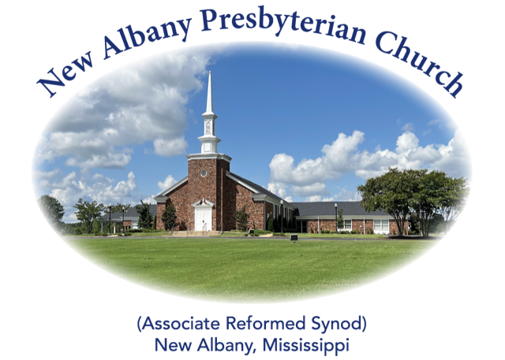

“I was glad when they said unto me, let us
go into the house of the Lord.”
Psalm 122:1
MORNING WORSHIP SERVICE
January 29, 2023
10:30 A.M.

But in fact Christ has been raised from the dead, the firstfruits of those who have fallen asleep. For as by a man came death, by a man has come also the resurrection of the dead. For as in Adam all die, so also in Christ shall all be made alive. (1 Corinthians 15:20-22)

As you enter the sanctuary may you quietly and reverently prepare your heart for the worship and praise of the Lord God.

We welcome our visitors to our services today. If you are a first-time visitor, please sign the guest book in the vestibule or drop a visitor’s card in the offering plate. Thanks! (Note: A nursery is provided for children through four years of age.) Membership is open to all who are trusting in Christ as Lord and Savior. Anyone interested should contact the pastor or one of the other officers. For more information, you may contact us by email at napresch@gmail.com or by calling the Church Office at 534-6060.

The Greetings and Announcements (10:25 A.M.)
The Minute for Missions
The Prelude The Strife Is O’er, the Battle Done Brunner
*The Choral Call to Worship O Sing to the Lord a New Song
*The Call to Worship
*The Gloria Patri
Glory be to the Father, and to the Son, and to the Holy Ghost; as it was in the beginning, is now, and pg. 735
ever shall be, world without end. Amen, Amen.
*The Invocation and Lord's Prayer
*The Opening Hymn, No. 276:1-3 Up from the Grave He Arose
The Children’s Sermon
The Responsive Reading Catechism #58 page 873
The Morning Prayer
The Giving of Tithes and Offerings
The Offertory Music I Know That My Redeemer Liveth Sanborn
*The Doxology
Praise God from Whom all blessings flow; praise Him all creatures here below; praise Him above, pg. 731
Ye heav’nly host; praise Father, Son, and Holy Ghost. Amen.
The Anthem Christ the Lord Is Risen Today Bradley Littlejohn
The Reading of God’s Word Luke 24:1-12
The Message Faith to Remember
*The Closing Hymn, No. 286:1-5 Worship Christ, the Risen King!
*The Benediction
*The Choral Benediction
The Postlude Jesus Christ Is Risen Today (Hymn 273)

*Congregation Standing if Able

THE ANNOUNCEMENTS

--WEDNESDAY EVENING ACTIVITIES: We will have our supper and service this Wednesday beginning at 6 P.M. Please sign the list on the bulletin board if you plan to eat. Thanks!
--LADIES BIBLE STUDY: The ladies will begin a Bible study on The Attributes of God, by Steven Lawson, on Tuesday, January 31, at 10:00 A.M. in the Fellowship Hall. All ladies are invited to attend.
--‘YOUNG AT HEART’ LUNCHEON: There will be a luncheon for our ‘Young at Heart’ following the morning worship service next Sunday, February 5. Please sign the list on the bulletin board if you plan to attend. Thanks!
--CHOIR GATHERING: Anyone who is already a member of the choir or anyone interested in participating in and with the choir this year is invited to the home of Don and Sharon Nichols on Friday, February 10, at 6:30 P.M. Bring your spouse or friend. This invite is for all lovers of the Lord’s music by voice or instrument. Reading music is not a requirement. Please come meet, greet and eat with us: 725 CR 54, New Albany.
--GAME TIME: There will be a game time every Thursday from 3:00-6:00 P.M. in the Fellowship Hall for anyone who is young at heart. Bring your favorite games to play. Please sign the list on the bulletin board if you are interested in participating even if you can’t make it every week.
--PARENTS’ NIGHT OUT: The youth, along with some adults from the church, will be providing a ‘parents night out’ on Friday, February 3, from 5:00-8:00 P.M. Just drop the kids off in the gym and we will have pizza, make Valentine’s Day crafts, and watch a movie. If you plan to send your child, please sign their name on the bulletin board and the type of pizza they prefer. If you are an adult wanting to serve by helping watch the kids, please let Ben know. Thanks!
--NURSERY ATTENDANT 1/29: Jeff and Amanda Covington, Diane and Katelyn Aldridge
--NURSERY ATTENDANT 2/5: Mac and Laura Fennell, Hannah Fennell, Avis Storment
--DEACONS ON DUTY: Jeff Covington, Lee Henson, Braxton Dowdy, Sam Cobb
--ELDER AT THE DOOR 1/29: Bradley Littlejohn
--ELDER AT THE DOOR 2/5: Robby Hall
--SANCTUARY FLOWERS: The flowers are given by Don and Sharon Nichols in gratitude for all of the blessings that have been bestowed on our Church family. As we continue through 2023, may we continue to support each other and our community in Christ.

I Know That My Redeemer Liveth

I know that my Redeemer liveth, and that He shall stand at the latter day upon
the earth and through worms destroy this body, yet in my flesh shall I see God.
For now is Christ risen from the dead, the first fruits of them that sleep.

