THE NEW ALBANY PRESBYTERIAN CHURCH
P.O. Box 906 – Highway 15 South
New Albany, Mississippi 38652

Church Office and Pastor Email
(662) 534-6060 napresch@gmail.com

THE SESSION
(Meeting 2nd Tuesday, Monthly)
Robby Hall - 2023 Al Campbell – 2025
John Harlow – 2023 Bradley Littlejohn – 2025
Don Nichols – 2024 Bruce Ballard – 2026
Will Henson – 2024 Thomas Maclin – 2026
THE DIACONATE
(Meeting 1st Sunday, Monthly)
Jeff Covington – 2023 John Taylor – 2024
Walt Henson – 2023 Ryan Murry – 2025
Lee Henson – 2023 Sam Cobb – 2026
Jonathon Morris – 2023 Braxton Dowdy – 2026
Harry Briscoe – 2024 Steven Lofton – 2026
Britt Jackson – 2024

WOMEN OF THE CHURCH
Mrs. Cassie Henson – President
Mrs. Grace Henson – Vice President
Mrs. Diane Aldridge – Sec./Treas.

STAFF
The Rev. William B. Everett………………….………………………………Pastor Emeritus
Mr. Stephen Ewing……………………………………………………………...Stated Supply
Mr. Ben Storment……………………………………….Dir. of Youth and Family Ministries
Mrs. Dana Hall…………………………………….......................................Church Secretary
Dr. Greg Long…………………………………...…………………………Minister of Music
Mrs. Sandy Coutoumanos……………………………………………………….…..Organist
Mrs. Denise Boatner…………………………………………………………………..Pianist
Mr. Shelby Lowery..………………………………………………Congregational Chairman
Mr. Bradley Littlejohn……………………………………………..Congregational Treasurer

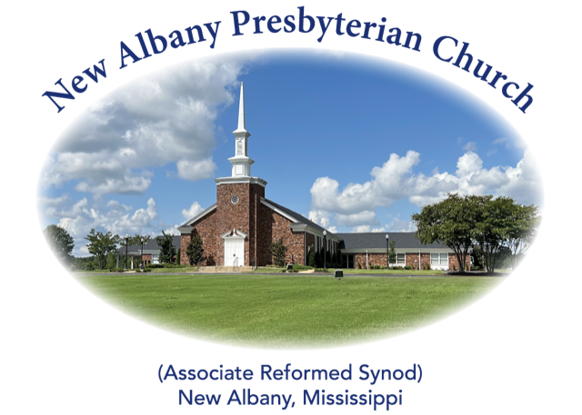

“I was glad when they said unto me, let us
go into the house of the Lord.”
Psalm 122:1
MORNING WORSHIP SERVICE
May 28, 2023
10:30 A.M.

Therefore, my beloved brothers, be steadfast, immovable, always abounding in the work of the Lord, knowing that in the Lord your labor is not in vain. (1 Corinthians 15:58)

As you enter the sanctuary may you quietly and reverently prepare your heart for the worship and praise of the Lord God.

We welcome our visitors to our services today. If you are a first-time visitor, please sign the guest book in the vestibule or drop a visitor’s card in the offering plate. Thanks! (Note: A nursery is provided for children through four years of age.) Membership is open to all who are trusting in Christ as Lord and Savior. Anyone interested should contact the pastor or one of the other officers. For more information, you may contact us by email at napresch@gmail.com or by calling the Church Office at 534-6060.

The Greetings and Announcements (10:25 A.M.)
The Minute for Missions
The Prelude God of Our Fathers Hustad
*The Choral Call to Worship Spirit of the Living God
*The Call to Worship
*The Gloria Patri
Glory be to the Father, and to the Son, and to the Holy Ghost; as it was in the beginning, is now, and pg. 735
ever shall be, world without end. Amen, Amen.
*The Invocation and Lord's Prayer
*The Opening Hymn, No. 598:1-3 Guide Me, O Thou Great Jehovah
The Children’s Sermon
The Responsive Reading Catechism #72 page 874
The Morning Prayer
The Giving of Tithes and Offerings
The Offertory Music America the Beautiful Wolford
*The Doxology
Praise God from Whom all blessings flow; praise Him all creatures here below; praise Him above, pg. 731
Ye heav’nly host; praise Father, Son, and Holy Ghost. Amen.
The Anthem Eternal Father, Strong to Save (Hymn 630) Suzanne and Cora Brockway
The Reading of God’s Word Colossians 3:18-4:1
The Message Working Hard or Hardly Working
*The Closing Hymn, No. 584:1,3,5,6 Go, Labor On
*The Benediction
*The Choral Benediction
The Postlude Eternal Father, Strong to Save

*Congregation Standing if Able

THE ANNOUNCEMENTS

--MEMORIAL DAY WEEKEND: In observance of this special holiday, we direct your attention to the two flags in the sanctuary. The American flag serves to remind us of the precious freedom we enjoy as Americans, while the Christian flag speaks of the even greater freedom that belongs to all who are in Christ. As we join our hearts to praise the Father for these freedoms, may we gratefully remember the price that was paid in blood to procure them for us.
--VACATION BIBLE SCHOOL: Our Vacation Bible School will be held June 5-9 from 9:00 A.M.-12:00 P.M. If you would like to help in any way, please let Ben know. Thanks!
--SUMMER CAMPS: If your child plans to attend any of the summer camps, please see Ben for registration information. Thanks!
--POOL PARTY: The youth will have a pool party for all ages at the home of Rick and Rita Murry, 1188 St. Hwy. 348, on May 31 from 4:00-7:00 P.M. Hamburgers and hotdogs will be served. If you are sending a child less than 12 years old, we ask that at least one parent stay to help monitor the pool. Please sign the sheet on the bulletin board if you plan to attend so we can make adequate preparations for the meal. Thanks!
--NURSERY ATTENDANT 5/28: Walt and Grace Henson, Steven and Susan Lofton
--NURSERY ATTENDANT 6/4: Robby and Dana Hall, Al and Valerie Campbell
--DEACONS ON DUTY: Britt Jackson, Steven Lofton, Walt Henson, Ryan Murry
--ELDER AT THE DOOR 5/28: Al Campbell
--ELDER AT THE DOOR 6/4 Bradley Littlejohn

*******

