THE NEW ALBANY PRESBYTERIAN CHURCH
P.O. Box 906 – Highway 15 South
New Albany, Mississippi 38652

Church Office and Pastor Email
(662) 534-6060 napresch@gmail.com

THE SESSION
(Meeting 2nd Tuesday, Monthly)
Robby Hall - 2023 Al Campbell – 2025
John Harlow – 2023 Bradley Littlejohn – 2025
Don Nichols – 2024 Bruce Ballard – 2026
Will Henson – 2024 Thomas Maclin – 2026
THE DIACONATE
(Meeting 1st Sunday, Monthly)
Jeff Covington – 2023 John Taylor – 2024
Walt Henson – 2023 Ryan Murry – 2025
Lee Henson – 2023 Sam Cobb – 2026
Jonathon Morris – 2023 Braxton Dowdy – 2026
Harry Briscoe – 2024 Steven Lofton – 2026
Britt Jackson – 2024

WOMEN OF THE CHURCH
Mrs. Cassie Henson – President
Mrs. Grace Henson – Vice President
Mrs. Diane Aldridge – Sec./Treas.

STAFF
The Rev. William B. Everett………………….………………………………Pastor Emeritus
Mr. Stephen Ewing……………………………………………………………...Stated Supply
Mr. Ben Storment……………………………………….Dir. of Youth and Family Ministries
Mrs. Dana Hall…………………………………….......................................Church Secretary
Dr. Greg Long…………………………………...…………………………Minister of Music
Mrs. Sandy Coutoumanos……………………………………………………….…..Organist
Mrs. Denise Boatner…………………………………………………………………..Pianist
Mr. Shelby Lowery..………………………………………………Congregational Chairman
Mr. Bradley Littlejohn……………………………………………..Congregational Treasurer

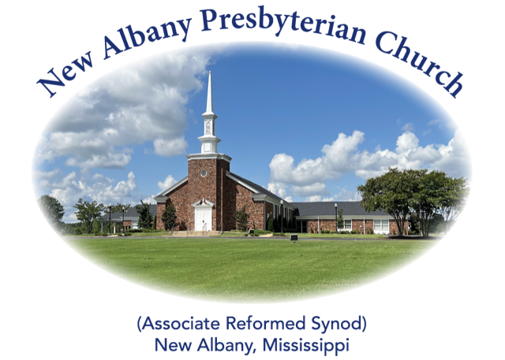

“I was glad when they said unto me, let us
go into the house of the Lord.”
Psalm 122:1
MORNING WORSHIP SERVICE
June 4, 2023
10:30 A.M.

And Jesus came and said to them, “All authority in heaven and on earth has been given to Me. Go therefore and make disciples of all nations, baptizing them in the name of the Father and of the Son and of the Holy Spirit, teaching them to observe all that I have commanded you. And behold, I am with you always, to the end of the age.” (Matthew 28:18-20)

As you enter the sanctuary may you quietly and reverently prepare your heart for the worship and praise of the Lord God.

We welcome our visitors to our services today. If you are a first-time visitor, please sign the guest book in the vestibule or drop a visitor’s card in the offering plate. Thanks! (Note: A nursery is provided for children through four years of age.) Membership is open to all who are trusting in Christ as Lord and Savior. Anyone interested should contact the pastor or one of the other officers. For more information, you may contact us by email at napresch@gmail.com or by calling the Church Office at 534-6060.

The Greetings and Announcements (10:25 A.M.)
The Minute for Missions
The Prelude Intercession and Joy (Bible Songs #37) Kerrick
*The Choral Call to Worship Spirit of the Living God
*The Call to Worship
*The Gloria Patri
Glory be to the Father, and to the Son, and to the Holy Ghost; as it was in the beginning, is now, and pg. 735
ever shall be, world without end. Amen, Amen.
*The Invocation and Lord's Prayer
*The Opening Hymn, No. 448:1-4 We Have Heard the Joyful Sound
The Children’s Sermon
The Responsive Reading Catechism #73 page 875
The Morning Prayer
The Giving of Tithes and Offerings
The Offertory Music Be Thou My Vision Kim
*The Doxology
Praise God from Whom all blessings flow; praise Him all creatures here below; praise Him above, pg. 731
Ye heav’nly host; praise Father, Son, and Holy Ghost. Amen.
The Anthem Come, Christians, Join to Sing
The Reading of God’s Word Colossians 4:2-6
The Message Evangelism 101
*The Closing Hymn, No. 561:1-4 Lord, Speak to Me That I May Speak
*The Benediction
*The Choral Benediction
The Postlude Lord of the Sabbath, Hear Us Pray (Hymn 390)

*Congregation Standing if Able

THE ANNOUNCEMENTS

--VACATION BIBLE SCHOOL: Our Vacation Bible School will be held this week from 9:00 A.M.-12:00 P.M. for Pre-K through Grade 5.
--CHURCH BREAKFAST: We will have our church breakfast next Sunday, June 11, beginning at 9:00 A.M. Come out and enjoy good food and fellowship.
--GOOD SAMARITAN SUNDAY: Next Sunday, June 11, we will receive donations and/or non-perishable food items for Good Samaritan.
--SUMMER CAMPS: If your child plans to attend any of the summer camps, please see Ben for registration information. Thanks!
--WEDDING INVITATION: Everyone is invited to the wedding of Meredith Prescott and Jack Cooper this Saturday, June 10, at 7:00 P.M. at The Jefferson in Oxford, MS.
--NURSERY ATTENDANT 6/4: Robby and Dana Hall, Al and Valerie Campbell
--NURSERY ATTENDANT 6/11: Braxton and Lindsay Dowdy, Sam and Emily Cobb
--DEACONS ON DUTY: Jonathon Morris, Harry Briscoe, John Taylor
--ELDER AT THE DOOR 6/4: Bradley Littlejohn
--ELDER AT THE DOOR 6/11: Robby Hall
--SANCTUARY FLOWERS: The flowers have been placed in the sanctuary by Dott Broussard to the glory of God and in honor of Lea Taylor on her birthday.

*******

