THE NEW ALBANY PRESBYTERIAN CHURCH
P.O. Box 906 – Highway 15 South
New Albany, Mississippi 38652

Church Office and Pastor Email
(662) 534-6060 napresch@gmail.com

THE SESSION
(Meeting 2nd Tuesday, Monthly)
Don Nichols – 2024 Bruce Ballard – 2026
Will Henson – 2024 Thomas Maclin – 2026
Al Campbell – 2025 Shelby Lowery – 2027
Bradley Littlejohn – 2025 Mac Fennell – 2027
THE DIACONATE
(Meeting 1st Sunday, Monthly)
Britt Jackson – 2024 Sam Cobb – 2026
Harry Briscoe – 2024 Braxton Dowdy – 2026
John Taylor – 2024 Steven Lofton – 2026
Ryan Murry – 2025 Tim Ewing – 2027
Patrick Brockway – 2027

WOMEN OF THE CHURCH
Mrs. Cassie Henson – President
Mrs. Grace Henson – Vice President
Mrs. Diane Aldridge – Sec./Treas.

STAFF
The Rev. William B. Everett………………….………………………………Pastor Emeritus
Mr. Stephen Ewing……………………………………………………………...Stated Supply
Mr. Ben Storment……………………………………….Dir. of Youth and Family Ministries
Mrs. Dana Hall…………………………………….......................................Church Secretary
Dr. Greg Long…………………………………...…………………………Minister of Music
Mrs. Sandy Coutoumanos……………………………………………………….…..Organist
Mrs. Denise Boatner…………………………………………………………………..Pianist
Mr. Al Campbell…..………………………………………………Congregational Chairman
Mr. Bradley Littlejohn……………………………………………..Congregational Treasurer

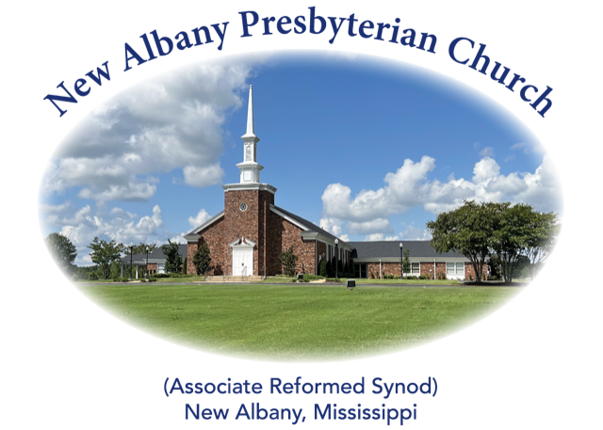

“I was glad when they said unto me, let us
go into the house of the Lord.”
Psalm 122:1
MORNING WORSHIP SERVICE
March 24, 2024
10:30 A.M.

“O death, where is your victory? O death, where is your sting?” The sting of death is sin, and the power of sin is the law. But thanks be to God, who gives us the victory through our Lord Jesus Christ. (1 Corinthians 15:55-57)

As you enter the sanctuary may you quietly and reverently prepare your heart for the worship and praise of the Lord God.

We welcome our visitors to our service today. If you are a first-time visitor, please sign the guest book in the vestibule or drop a visitor’s card in the offering plate. Thanks! (Note: A nursery is provided for children through four years of age.) Membership is open to all who are trusting in Christ as Lord and Savior. Anyone interested should contact the pastor or one of the other officers. For more information, you may contact us by email at napresch@gmail.com or by calling the Church Office at 534-6060.

The Greetings and Announcements (10:25 A.M.)
The Prelude Crown Him with Many Crowns Kim
*The Choral Call to Worship Worthy Is the Lamb
*The Call to Worship
*The Gloria Patri
Glory be to the Father, and to the Son, and to the Holy Ghost; as it was in the beginning, is now, and pg. 735
ever shall be, world without end. Amen, Amen.
*The Invocation and Lord's Prayer
*The Opening Hymn, No. 235:1-3 All Glory, Laud, and Honor
The Children’s Sermon
The Sacrament of Baptism
*The Hymn, No. 417:1-5 A Little Child the Savior Came
The Morning Prayer
The Giving of Tithes and Offerings
The Offertory Music Palm Sunday Medley Schram
*The Doxology
Praise God from Whom all blessings flow; praise Him all creatures here below; praise Him above, pg. 731
Ye heav’nly host; praise Father, Son, and Holy Ghost. Amen.
The Anthem Blessed Is the King
The Reading of God’s Word Mark 6:1-6
The Message The Utter Folly of Unbelief
*The Closing Hymn, No. 679:1-4 ‘Tis So Sweet to Trust in Jesus
*The Benediction
*The Choral Benediction
The Postlude All Glory, Laud, and Honor

*Congregation Standing if Able

THE ANNOUNCEMENTS

--WEDNESDAY ACTIVITIES: Children’s Choir will begin each week at 5:15 in the CAC, supper at 6:00, Bible study at 6:20, youth meeting at 6:30 and adult choir practice at 7:00.
--SACRAMENT OF BAPTISM: Charlotte Jane Boatner, daughter of John and Chloe Boatner, will receive the sacrament of baptism at our worship service this morning. We thank Rev. Bill Everett for filling the pulpit this morning and administering the sacrament.
--MAUNDY THURSDAY: We will have our Maundy Thursday Communion service this Thursday, March 28, at 6:00 P.M.
--CHURCH EGG HUNT: We will have an egg hunt on Saturday, March 30, from 2:00-3:30 P.M. at the church. If you would like to donate eggs and/or candy, please bring them to the church by Thursday, March 28. Thanks!
--EASTER OFFERING: Envelopes have been provided for our special offering to help with the work of our denomination.
--ORDINATION AND INSTALLATION SERVICE AND RECEPTION: A reception celebrating Stephen’s ordination will immediately follow the service on Sunday, April 7, and will be held in the CAC. The service will begin at 5:00 P.M. All ladies of the church are asked to provide sweets (cookies, brownies, etc.) for the event. There will be a sign-up sheet available on the bulletin board if you can provide a finger food dessert. (NOTE: The Ordination Reception Committee will meet in the Fellowship Hall immediately following our worship service this morning.)
--LADIES BIBLE STUDY: Tuesdays at 10:00 A.M. in the church library.
--NURSERY ATTENDANT 3/24: Mac and Laura Fennell, Hannah Fennell, Avis Storment
--NURSERY ATTENDANT 3/31: Ryan and Jordan Murry, Rita Murry
--DEACONS ON DUTY: Patrick Brockway, John Taylor, Harry Briscoe
--ELDER AT THE DOOR 3/24: Thomas Maclin
--ELDER AT THE DOOR 3/31: Bruce Ballard
--SANCTUARY FLOWERS: The flowers have been placed in the sanctuary by Jeff and Amanda Covington to the glory of God and in honor of their daughter, Annie, on her 8th birthday.

*******

