THE NEW ALBANY PRESBYTERIAN CHURCH
P.O. Box 906 – Highway 15 South
New Albany, Mississippi 38652

Church Office and Pastor Email
(662) 534-6060 napresch@gmail.com

THE SESSION
(Meeting 2nd Tuesday, Monthly)
Don Nichols – 2024 Bruce Ballard – 2026
Will Henson – 2024 Thomas Maclin – 2026
Al Campbell – 2025 Shelby Lowery – 2027
Bradley Littlejohn – 2025 Mac Fennell – 2027
THE DIACONATE
(Meeting 1st Sunday, Monthly)
Britt Jackson – 2024 Sam Cobb – 2026
Harry Briscoe – 2024 Braxton Dowdy – 2026
John Taylor – 2024 Steven Lofton – 2026
Ryan Murry – 2025 Tim Ewing – 2027
Patrick Brockway – 2027

WOMEN OF THE CHURCH
Mrs. Cassie Henson – President
Mrs. Grace Henson – Vice President
Mrs. Diane Aldridge – Sec./Treas.

STAFF
The Rev. William B. Everett………………….………………………………Pastor Emeritus
Mr. Stephen Ewing……………………………………………………………...Stated Supply
Mr. Ben Storment……………………………………….Dir. of Youth and Family Ministries
Mrs. Dana Hall…………………………………….......................................Church Secretary
Dr. Greg Long…………………………………...…………………………Minister of Music
Mrs. Sandy Coutoumanos……………………………………………………….…..Organist
Mrs. Denise Boatner…………………………………………………………………..Pianist
Mr. Al Campbell…..………………………………………………Congregational Chairman
Mr. Bradley Littlejohn……………………………………………..Congregational Treasurer

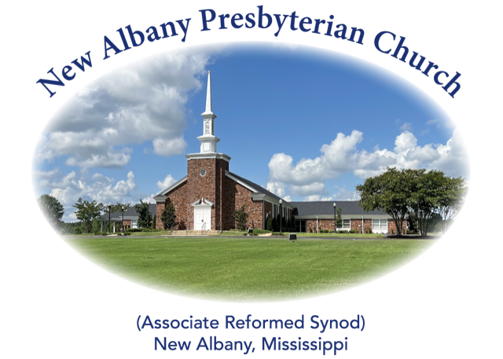

“I was glad when they said unto me, let us
go into the house of the Lord.”
Psalm 122:1
MORNING WORSHIP SERVICE
March 31, 2024
10:30 A.M.

Blessed be the God and Father of our Lord Jesus Christ! According to His great mercy, He has caused us to be born again to a living hope through the resurrection of Jesus Christ from the dead, to an inheritance that is imperishable, undefiled, and unfading, kept in heaven for you, who by God's power are being guarded through faith for a salvation ready to be revealed in the last time. (1 Peter 1:3-5)

As you enter the sanctuary may you quietly and reverently prepare your heart for the worship and praise of the Lord God.

We welcome our visitors to our service today. If you are a first-time visitor, please sign the guest book in the vestibule or drop a visitor’s card in the offering plate. Thanks! (Note: A nursery is provided for children through four years of age.) Membership is open to all who are trusting in Christ as Lord and Savior. Anyone interested should contact the pastor or one of the other officers. For more information, you may contact us by email at napresch@gmail.com or by calling the Church Office at 534-6060.

The Greetings and Announcements (10:25 A.M.)
The Prelude All Creatures of Our God and King
*The Choral Call to Worship Christ the Lord Is Risen Today Children’s Choir
*The Call to Worship
*The Gloria Patri
Glory be to the Father, and to the Son, and to the Holy Ghost; as it was in the beginning, is now, and pg. 735
ever shall be, world without end. Amen, Amen.
*The Invocation and Lord's Prayer
*The Opening Hymn, No. 276:1-3 Up from the Grave He Arose
The Children’s Sermon
The Morning Prayer
The Giving of Tithes and Offerings
The Offertory Music Jesus Shall Reign Hatton
*The Doxology
Praise God from Whom all blessings flow; praise Him all creatures here below; praise Him above, pg. 731
Ye heav’nly host; praise Father, Son, and Holy Ghost. Amen.
The Anthem Glory to the Risen Lamb
The Reading of God’s Word 1 Corinthians 15:12-28
The Message The Death of Death
*The Closing Hymn, No. 286:1-5 Worship Christ, the Risen King!
*The Benediction
*The Choral Benediction Worthy Is the Lamb
The Postlude

*Congregation Standing if Able

THE ANNOUNCEMENTS

--WEDNESDAY ACTIVITIES: Children’s Choir will begin each week at 5:15 in the CAC, supper at 6:00, Bible study at 6:20, youth meeting at 6:30 and adult choir practice at 7:00.
--ORDINATION AND INSTALLATION SERVICE AND RECEPTION: A reception celebrating Stephen’s ordination will immediately follow the service next Sunday, April 7, and will be held in the CAC. The service will begin at 5:00 P.M. All ladies of the church are asked to provide sweets (cookies, brownies, etc.) for the event. There is a sign-up sheet available on the bulletin board if you can provide a finger food dessert.
--LADIES BIBLE STUDY: Tuesdays at 10:00 A.M. in the church library.
--NURSERY ATTENDANT 3/31: Ryan and Jordan Murry, Rita Murry
--NURSERY ATTENDANT 4/7: Forrest and Mary Beth Crumby, Susan and Anna Kat Tate
--DEACONS ON DUTY: Patrick Brockway, John Taylor, Harry Briscoe
--ELDER AT THE DOOR 3/31: Bruce Ballard
--ELDER AT THE DOOR 4/7: Al Campbell
--SANCTUARY FLOWERS: The flowers have been placed in the sanctuary by Jeff, Connie, and Gwyn Pennebaker to the glory of God and in loving memory of Dr. and Mrs. D. M. Pennebaker, John David, Robert, and Sam Pennbaker.

He is not here, for He has risen!

******

