THE NEW ALBANY PRESBYTERIAN CHURCH
P.O. Box 906 – Highway 15 South
New Albany, Mississippi 38652

Church Office and Pastor Email
(662) 534-6060 napresch@gmail.com

THE SESSION
(Meeting 2nd Tuesday, Monthly)
Don Nichols – 2024 Bruce Ballard – 2026
Will Henson – 2024 Thomas Maclin – 2026
Al Campbell – 2025 Shelby Lowery – 2027
Bradley Littlejohn – 2025 Mac Fennell – 2027
THE DIACONATE
(Meeting 1st Sunday, Monthly)
Britt Jackson – 2024 Sam Cobb – 2026
Harry Briscoe – 2024 Braxton Dowdy – 2026
John Taylor – 2024 Steven Lofton – 2026
Ryan Murry – 2025 Tim Ewing – 2027
Patrick Brockway – 2027

WOMEN OF THE CHURCH
Mrs. Cassie Henson – President
Mrs. Grace Henson – Vice President
Mrs. Diane Aldridge – Sec./Treas.

STAFF
The Rev. Stephen Ewing………………….…………………………………………….Pastor
The Rev. William B. Everett…………………………………………….........Pastor Emeritus
Mr. Ben Storment……………………………………….Dir. of Youth and Family Ministries
Mrs. Dana Hall…………………………………….......................................Church Secretary
Dr. Greg Long…………………………………...…………………………Minister of Music
Mrs. Sandy Coutoumanos……………………………………………………….…..Organist
Mrs. Denise Boatner…………………………………………………………………..Pianist
Mr. Al Campbell…..………………………………………………Congregational Chairman
Mr. Bradley Littlejohn……………………………………………..Congregational Treasurer

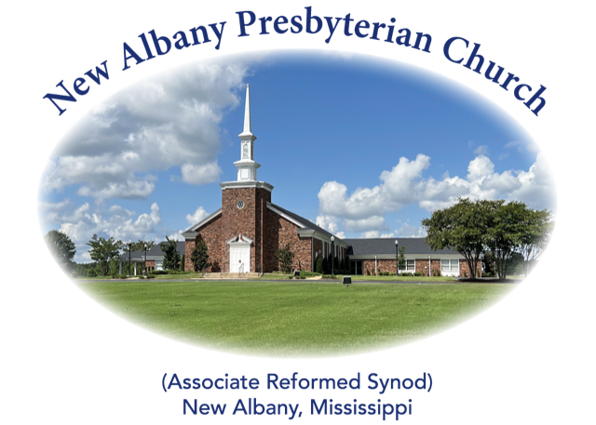

“I was glad when they said unto me, let us
go into the house of the Lord.”
Psalm 122:1
MORNING WORSHIP SERVICE
April 28, 2024
10:30 A.M.

In Him we have obtained an inheritance, having been predestined according to the purpose of Him who works all things according to the counsel of His will, so that we who were the first to hope in Christ might be to the praise of His glory. (Ephesians 1:11-12)

As you enter the sanctuary may you quietly and reverently prepare your heart for the worship and praise of the Lord God.

We welcome our visitors to our service today. If you are a first-time visitor, please sign the guest book in the vestibule or drop a visitor’s card in the offering plate. Thanks! (Note: A nursery is provided for children through four years of age.) Membership is open to all who are trusting in Christ as Lord and Savior. Anyone interested should contact the pastor or one of the other officers. For more information, you may contact us by email at napresch@gmail.com or by calling the Church Office at 534-6060.

The Greetings and Announcements (10:25 A.M.)
The Minute for Missions
The Prelude O Worship the King Keveren
*The Choral Call to Worship O My Soul, Praise the Lord Most High
*The Call to Worship
*The Gloria Patri
Glory be to the Father, and to the Son, and to the Holy Ghost; as it was in the beginning, is now, and pg. 735
ever shall be, world without end. Amen, Amen.
*The Invocation and Lord's Prayer
*The Opening Hymn, No. 172:1-5 Let Us Love and Sing and Wonder
The Children’s Sermon
The Sacrament of Baptism
*The Baptism Hymn, No. 416:1,4 Gracious Savior, Gentle Shepherd
The Morning Prayer
The Giving of Tithes and Offerings
The Offertory Music When We Walk with the Lord Young
*The Doxology
Praise God from Whom all blessings flow; praise Him all creatures here below; praise Him above, pg. 731
Ye heav’nly host; praise Father, Son, and Holy Ghost. Amen.
The Anthem Classic Praise
The Reading of God’s Word Joshua 13-21
The Message Lessons from the Allotment: A Full Inheritance
*The Closing Hymn, No. 691:1-4 It Is Well with My Soul
*The Benediction
*The Choral Benediction
The Postlude Jesus Loves the Little Children

*Congregation Standing if Able
THE ANNOUNCEMENTS

--WEDNESDAY ACTIVITIES: Children’s Choir will begin each week at 5:15 in the CAC, supper at 6:00, Bible study at 6:20, youth meeting at 6:30 and adult choir practice at 7:00.
--SACRAMENT OF BAPTISM: Bryar Reade Dowdy, son of Braxton and Lindsay Dowdy, will receive the sacrament of baptism this morning.
--NEW MEMBERS CLASS: A new members class is being held during the Sunday School hour in the church library.
--YOUTH FUNDRAISER: The youth will have a fundraiser luncheon next Sunday, May 5, in the CAC following the worship service to help raise money for camps. Last year we spent a large amount of funds on youth camp tuition alone and the prices are even higher this year. Please sign the list on the bulletin board by Wednesday if you plan to attend so we can make adequate preparations. Thank you for always supporting and praying for our youth!
--LADIES BIBLE STUDY: All ladies are invited to a Bible study, Sojourners and Exiles, by Sinclair Ferguson, on Tuesdays at 10:00 A.M. in the church library.
--NURSERY ATTENDANT 4/28: Don and Sharon Nichols, Will and Lori Henson
--NURSERY ATTENDANT 5/5: Walt and Grace Henson, Jonathon and Sarah Kathryn Morris
--DEACONS ON DUTY: Braxton Dowdy, Tim Ewing, Sam Cobb
--ELDER AT THE DOOR 4/28: Don Nichols
--ELDER AT THE DOOR 5/5: John Harlow
--SANCTUARY FLOWERS: The flowers have been placed in the sanctuary by Jeff and Amanda Covington to the glory of God and in honor of their daughter, Ava, on her 6th birthday.

*****

