THE NEW ALBANY PRESBYTERIAN CHURCH
P.O. Box 906 – Highway 15 South
New Albany, Mississippi 38652

Church Office and Pastor Email
(662) 534-6060 napresch@gmail.com

THE SESSION
(Meeting 2nd Tuesday, Monthly)
Don Nichols – 2024 Bruce Ballard – 2026
Will Henson – 2024 Thomas Maclin – 2026
Al Campbell – 2025 Shelby Lowery – 2027
Bradley Littlejohn – 2025 Mac Fennell – 2027
THE DIACONATE
(Meeting 1st Sunday, Monthly)
Britt Jackson – 2024 Sam Cobb – 2026
Harry Briscoe – 2024 Braxton Dowdy – 2026
John Taylor – 2024 Steven Lofton – 2026
Ryan Murry – 2025 Tim Ewing – 2027
Patrick Brockway – 2027

WOMEN OF THE CHURCH
Mrs. Cassie Henson – President
Mrs. Grace Henson – Vice President
Mrs. Diane Aldridge – Sec./Treas.

STAFF
The Rev. Stephen Ewing………………….…………………………………………….Pastor
The Rev. William B. Everett…………………………………………….........Pastor Emeritus
Mr. Ben Storment……………………………………….Dir. of Youth and Family Ministries
Mrs. Dana Hall…………………………………….......................................Church Secretary
Dr. Greg Long…………………………………...…………………………Minister of Music
Mrs. Sandy Coutoumanos……………………………………………………….…..Organist
Mrs. Denise Boatner…………………………………………………………………..Pianist
Mr. Al Campbell…..………………………………………………Congregational Chairman
Mr. Bradley Littlejohn……………………………………………..Congregational Treasurer

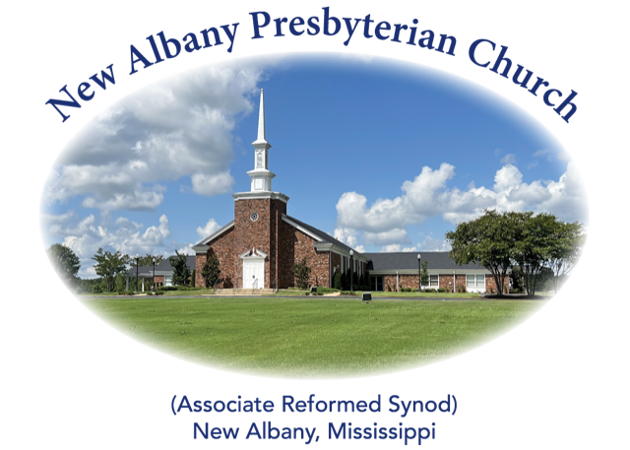

“I was glad when they said unto me, let us
go into the house of the Lord.”
Psalm 122:1
MORNING WORSHIP SERVICE
April 21, 2024
10:30 A.M.

Fear not, for I am with you; be not dismayed, for I am your God; I will strengthen you, I will help you, I will uphold you with My righteous right hand. (Isaiah 41:10)

As you enter the sanctuary may you quietly and reverently prepare your heart for the worship and praise of the Lord God.

We welcome our visitors to our service today. If you are a first-time visitor, please sign the guest book in the vestibule or drop a visitor’s card in the offering plate. Thanks! (Note: A nursery is provided for children through four years of age.) Membership is open to all who are trusting in Christ as Lord and Savior. Anyone interested should contact the pastor or one of the other officers. For more information, you may contact us by email at napresch@gmail.com or by calling the Church Office at 534-6060.

The Greetings and Announcements (10:25 A.M.)
The Minute for Missions
The Prelude Lead On, O King Eternal Bock
*The Choral Call to Worship O My Soul, Praise the Lord Most High
*The Call to Worship
*The Gloria Patri
Glory be to the Father, and to the Son, and to the Holy Ghost; as it was in the beginning, is now, and pg. 735
ever shall be, world without end. Amen, Amen.
*The Invocation and Lord's Prayer
*The Opening Hymn, No. 302:1-3 Come, Christians, Join to Sing
The Children’s Sermon
The Responsive Reading Catechism #106 page 877
The Morning Prayer
The Giving of Tithes and Offerings
The Offertory Music Sun of My Soul Sikes
*The Doxology
Praise God from Whom all blessings flow; praise Him all creatures here below; praise Him above, pg. 731
Ye heav’nly host; praise Father, Son, and Holy Ghost. Amen.
The Anthem Psalm 121
The Reading of God’s Word Joshua 10:29-12:24
The Message The Full Extent of God’s Control
*The Closing Hymn, No. 616:1-3 Leaning on the Everlasting Arms
*The Benediction
*The Choral Benediction
The Postlude All Hail the Power of Jesus’ Name

*Congregation Standing if Able

THE ANNOUNCEMENTS

--WEDNESDAY ACTIVITIES: Children’s Choir will begin each week at 5:15 in the CAC, supper at 6:00, Bible study at 6:20, youth meeting at 6:30 and adult choir practice at 7:00.
--NEW MEMBERS CLASS: A new members class is being held during the Sunday School hour in the church library.
--YOUTH FUNDRAISER: The youth will have a fundraiser luncheon on Sunday, May 5, following the worship service to help raise money for camps. Last year we spent a large amount of funds on youth camp tuition alone and the prices are even higher this year. Please sign the list on the bulletin board if you plan to attend so we can make adequate preparations. Thank you for always supporting and praying for our youth!
--LADIES BIBLE STUDY: All ladies are invited to a Bible study, Sojourners and Exiles, by Sinclair Ferguson, on Tuesdays at 10:00 A.M. in the church library.
--NURSERY ATTENDANT 4/21: Steven and Susan Lofton, John and Laurie Harlow
--NURSERY ATTENDANT 4/28: Don and Sharon Nichols, Will and Lori Henson
--DEACONS ON DUTY: Braxton Dowdy, Tim Ewing, Sam Cobb
--ELDER AT THE DOOR 4/21: Robby Hall
--ELDER AT THE DOOR 4/28: Don Nichols
--SANCTUARY FLOWERS: The flowers have been placed in the sanctuary by Vicki Harmon to the glory of God and in honor of our pastor, Stephen Ewing.

*****

